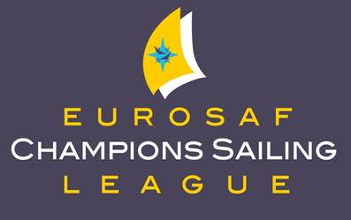
EUROSAF Champions Sailing League
For Olympic Classes
A new series of championship regattas will be organised in Europe next year, under the name EUROSAF Champions Sailing League® using the above logo. The new series, which incorporates all Olympic disciplines, had previously been announced in May of this year. These regattas will incorporate new innovations in race formats that will make sailing easier to follow and more attractive for sailors, media and spectators alike.
The EUROSAF Champions Sailing League® will be staged over five professionally organised events, starting in May 2013 at the Fraglia Vela Riva, Lake Garda, Italy. The Dutch Delta Lloyd Regatta in Medemblik is next, followed by Sail for Gold at the 2012 Olympic venue of Weymouth & Portland in the UK. Kieler Woche in Germany will be the fourth event in the series, which will conclude later in the year with the Semaine Olympique Française, at La Rochelle, France. The first four events take place in the ISAF defined ‘European Window’ and all five events qualify for ISAF ranking points.
The EUROSAF Champions Sailing League® will accept entries from sailors from all over the world and will be a great opportunity to sail against competitors in an inspiring way. Teams coming from Europe and around the world, will be able to compete in four high quality Olympic classes regattas within two months starting at the beginning of May and concluding at the end of June, with a grand finale in France later in the year. Two months of extraordinary Olympic classes competition, all in one continent.
More information will be published soon, with further announcements expected in November.

EUROSAF Champions Sailing League, Calendar
For Olympic Classes
The dates for 2013 and 2014, for all five EUROSAF Champions Sailing League® events, have been confirmed and are as follows:
2013 |  | 2014
Event 1 |  | Event 1
Fraglia Vela Riva |  | Fraglia Vela Riva
8th – 12th May |  | 7th – 11th May
Riva del Garda - Italy |  | Riva del Garda - Italy
Event 2 |  | Event 2
Delta Lloyd Regatta |  | Delta Lloyd Regatta
21st – 25th May |  | 20th – 24th May
Medemblik – The Netherlands |  | Medemblik – The Netherlands
Event 3 |  | Event 3
Sail for Gold |  | Sail for Gold
8th – 12th June |  | 7th – 12th June
Weymouth – United Kingdom |  | Weymouth – United Kingdom
Event 4 |  | Event 4
Kieler Woche |  | Kieler Woche
22nd – 26th June |  | 21st – 25th June
Kiel - Germany |  | Kiel - Germany
Event 5 |  | Event 5
Semaine Olympique Française |  | Semaine Olympique Française
9th – 13th October |  | 22nd – 25th September
La Rochelle - France |  | La Rochelle - France
To contact EUROSAF please email John Friend at pressoffice@eurosaf.org or telephone contact +44 161 761 0077. Interviews with officials by arrangement.

